Calculation of Distribution Factors

PTDF and LODF

Sai Sri Harsha Chandavarapu

Shreeganesh Bhat

December 15, 2015

Abstract

Distribution factors are used mainly in security and contingency analysis. They are used to approximately determine the impact of generation and load on transmission flows. Objective of this project is to calculate two of such factors - Power Transfer Distribution Factor (PTDF) and Load Outage Distribution factor (LODF). PTDF calculates a relative change in power flow on a particular line due to a change in injection and corresponding withdrawal at a pair of busses and LODF calculates a redistribution of power in the system in case of an outage. Additionally, sparse matrix techniques are used in MATLAB to handle large power systems efficiently.

**Table of Contents**

1. **List of Figures** 4
2. **Introduction** 5

**1.1** **Distribution Factors** 5

1.1.1 Power Transfer Distribution Factor (PTDF) 5

1.1.2 Line Outage Distribution Factor (LODF) 6

**1.2** **DC Power Flow** 6

**1.3** **Inverse of a Matrix using LU Decomposition** 7

**1.4** **Sparse matrix techniques in power systems** 8

1. **Solution to the Problem** 9

**2.1** **Power Transfer Distribution factor Calculation** 9

2.1.1 Without Radial Lines 9

2.1.2 Radial Lines 11

2.1.3 Solution to PTDF computation from any bus to any bus 11

**2.2** **Load Outage Distribution factor Calculation** 16

2.2.1 Normal Case 16

2.2.2 Special Case 17

1. **Description of MATLAB programs and User Manual** 18

**3.1** **Description of MATLAB programs** 18

**3.2** **User Manual** 20

3.2.1 Description 20

3.2.2 Procedure to Run the Program: 21

1. **Conclusion** 22
2. **References** 23
3. **Program Output** 24

**Test Case: 6 bus System:** 24

# **List of Figures**

# 

Figure 1 Change in power flow in line 5

Figure 2 Change in flow due to line outage 6

Figure 3 IEEE 6 bus system 11

Figure 4 PTDF table for 6 bus system 12

Figure 5 transaction between bus 4 and 6 12

Figure 6 simulation in PowerWorld 13

Figure 7 % PTDF values corresponding to three different transactions 14

Figure 8 Six bus graph equivalent 27

**Chapter 1**

# **Introduction**

In order to monitor operational reliability, power system operators rely heavily on online studies using a model of the system obtained offline [1]. It help operators in understanding the behavior of the system. These studies may include calculating a relative change in power flow on a particular line due to a change in injection and corresponding withdrawal at a pair of busses or determining whether or not the system will meet operational reliability requirements in case of outage in any one particular asset like a generator or a transmission line [2]. This project report describes one such method which calculates linear sensitivity distribution factors (DFs) such as power transfer distribution factors (PTDFs) and line outage distribution factors (LODFs). These factors can be used in model-based online study to determine if system is secure.

## **Distribution Factors**

Distribution factors are linearized sensitivities used in online contingency analysis, generation re-dispatch, and congestion relief etc. They show how a power flow variable such as flow, voltage, phase angle, etc. change with the change of another value such as injection, flow etc. Various distribution factors are defined as follows:

1. Line Outage Distribution Factors (LODF)
2. Power Transfer Distribution Factors (PTDF)
3. Line Closure Distribution Factor (LCDF)
4. Outage transfer distribution factor (OTDF)

In this project, we are concentrating on Power Transfer Distribution Factors (PTDF) and Line Outage Distribution Factors (LODF).

* + 1. Power Transfer Distribution Factor (PTDF)

NERC defines a Power Transfer Distribution Factor as “In the pre-contingency configuration of a system under study, a measure of the responsiveness or change in electrical loadings on transmission system Facilities due to a change in electric power transfer from one area to another, expressed in percent (up to 100%) of the change in power transfer”[3].

In general, PTDF is the relative change in power flow on a particular line due to power injection and corresponding withdrawal at a pair of busses. For example, consider a pair of buses, “m” and “n” and a transmission line “*l*”, which is connected between the pair of buses “*i*” and “*j*”.

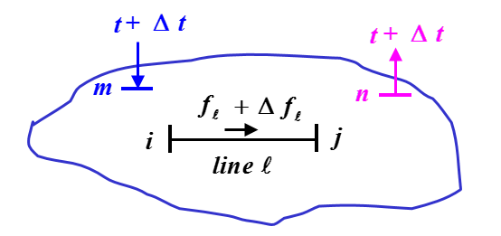

Figure Change in power flow in line

Assume initially, flow through the line “*l*” is “fl”. Now imagine, “Δt” amount of power has been injected at the bus “m” and the same amount is withdrawn at the bus n. Now, this transaction causes additional flow $"Δf_{l}"$ on the line “*l*”. The additional amount of power that flows over the line due to the injection and withdraw of power “Δt” is given by PTDF. It is represented as $φ_{l}^{(w)}$

$$PTDF (φ_{l}^{\left(w\right)})= \frac{Δf_{l}}{Δt}$$

In this project, DC power flow method is used to determine Power Transfer Distribution Factor.

* + 1. Line Outage Distribution Factor (LODF)

Power system operation is practically always limited by contingencies, with line outages comprising a large number of the contingencies. We desire to determine the impact of a line outage on the change in real power flow across the system. These values are provided by the LODFs. Line outage distribution factors (LODFs) are utilized to perform contingency analysis in power systems.

When an outage occurs, the power flowing over the outage line is redistributed onto the remaining lines in the system.

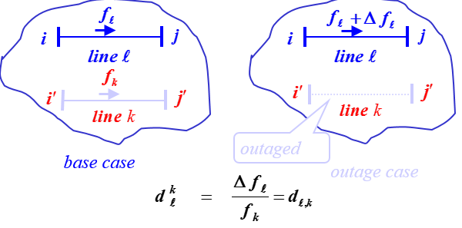

Figure Change in flow due to line outage

Since each contingency requires separate LODFs, a quick calculation of LODFs, especially with multiple-line outages, could speed up contingency analysis and significantly improve the security analysis of the power system. This project provides a direct method for expressing LODFs in terms of power transfer distribution factors (PTDFs) of pre-contingency network. Simple matrix calculations are required in the proposed approach for a fast evaluation of LODFs.

* 1. **DC Power Flow**

In order to reduce the calculation time, DC Power flow method has been used to solve power flow problem.

Problem is simplified by making the system linear by making following assumptions:

1. Line resistances (active power losses) are negligible i.e. R << X.
2. Voltage angle differences are assumed to be small i.e. sin (Θ) = Θ and cos (Θ) = 1.
3. Magnitudes of bus voltages are set to 1.0 per unit (flat voltage profile).
4. Tap settings are ignored

Based on these assumptions, voltage angles and active power injections are the variables of DCPF. Active power injections are known in advance. Therefore,



In which, Bij is the reciprocal of the reactance between bus “i” and bus “j” and Bij is the imaginary part of Yij. As a result, active power flow through transmission line “i”, between buses “s” and “r”, can be calculated as [4] :



Where XLi is the reactance of line “I”.

DC power flow equations in the matrix form and the corresponding matrix relation for flows through branches are represented as



Where,

P is N x 1 vector of bus active power injections for buses 1 … N

B is N x N admittance matrix with R = 0

Θ is N x 1 vector of bus voltage angles for buses 1 … N

PL is M x 1 vector of branch flows (M is the number of branches)

b is M x M matrix (bkk is equal to the susceptance of line k and non-diagonal elements are zero)

A is M x N bus-branch incidence matrix

* 1. **Inverse of a Matrix using LU Decomposition**

As we can see from above, solution to the DC power flow method involves inversion of the susceptance matrix B. Since power systems are very large in practice, it is necessary to invert this matrix without actually using the inverse function in MTALAB as this takes lot of computation effort and sometimes, this may return a bad value. So, instead using an inverse function, LU Decomposition method has been used to invert the susceptance matrix.

In general, inverse using LU Decomposition involves following steps.

1. Decomposition
2. Forward substitution
3. Backward substitution

Let's start with an Ax=b problem. A is an nxn matrix and b is an nx1 column vector. We are trying to solve for the nx1 column vector x.

The idea is that we break A into two matrices: L, which is a lower triangular matrix, and U, which is an upper triangular matrix. It would look something like this:

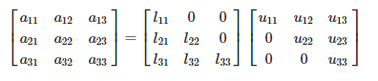

Our original equation then becomes



In the matrix form,

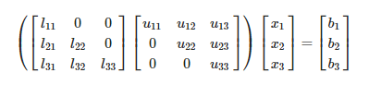

If we shift the parentheses, we get the following:

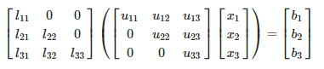

Looking just inside the parentheses, we can see another Ax=b type problem. If we say that Ux=d, where d is a different column vector, we have 2 separate Ax=b type problems:

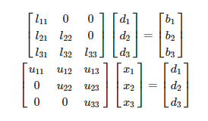

If we look at the problems, the matrices on the left are in a form like row echelon form. Using forward and back substitutions, we can solve easily for all the elements of the x and d matrices. We first solve Ld=b for d, then we substitute into Ux=d to solve for x.

* 1. **Sparse matrix techniques in power systems**

In power system computations, one finds different types of matrices like admittance matrices, impedance matrices, Jacobian matrices and various others. Usually, due to the topology of the power system, the admittance matrices and Jacobian matrices are extremely sparse. For larger systems the size of the admittance matrices prohibits storing all elements in them. So in this project, in order to save the memory and increase the computational efficiency, sparse techniques are used in MATLAB.

**Chapter 2**

# **Solution to the Problem**

* 1. **Power Transfer Distribution factor Calculation**
     1. Without Radial Lines

The power flow equation for bus phase angles in terms of injected power in per unit is:

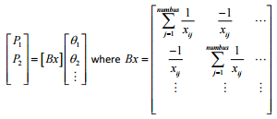

Note here that “Bx” is a singular matrix. To make this matrix non-singular, we zero out the row of “Bx” corresponding to the reference bus and then set the diagonal term of the reference bus row to 1. Now this matrix “Bx_alt” can be inverted and we have called this reduced matrix as “Bx_alt” in our program



We use LU Decomposition method explained above to invert the matrix and we call the inverted matrix “X_alt”. After inverting, we set the term X_alt(refbus,refbus) = 0. Then,



This is the PTDF giving the fraction of power that is sent into the network at bus s (source bus) to the r bus (receiving bus) which flows over line from bus I to bus j. Instead of using line ‘l’ throughout this derivation, we shall refer to line as line ij so that the formula for PTDF becomes:



The Matlab program uses this statement to generate the PTDF table:



The PTDF matrix has rows corresponding to the ij lines, the columns correspond to the sr lines. NOTE that strictly speaking, the combination sr can actually be any pair of buses in the entire network, not just pairs at the ends of lines, here we use a restricted definition of the PTDF that corresponds to sr pairs that are lines ends in the network. If we are ignoring radial lines then the “A_alt” matrix is just the original A matrix so that the expression becomes:



Where,

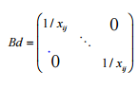

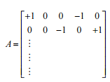

The entry = +1 if i is the line ij from bus, and entry = -1 if j is the line ij to bus.

The dimensions of the A matrix is numline X numbus. Now, we will start with the X_alt matrix and look only at four terms: the is, ir, js, and jr terms. We will multiply this matrix by the A matrix and only look at the row corresponding to line ij. We will then post multiply by the AT matrix and only look at its column corresponding to line sr. Schematically this looks like this:

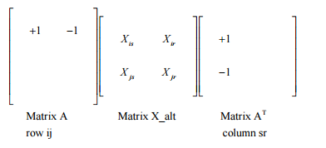

The resulting product is a matrix of dimension numline X numline and the terms created by the multiplication above are the terms in row ij and column sr equal to: 

We complete the PTDF calculation by multiplying with the Bd matrix

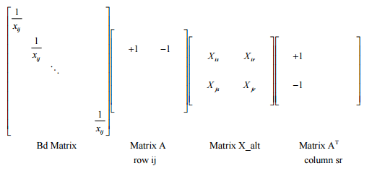

Where each term of the result is



* + 1. Radial Lines

To deal with radial lines, the Matlab program first finds all buses with only one line connected – that is the radial bus. It then builds a vector called RadialLines and then counts the number of radial lines in the system. The table RadialLines is simply a list of indices of radial lines. In the calculation of the PTDF factors we start with the original A matrix and copy it into a matrix called A_alt. Then the corresponding radial bus for any radial line is set to zero in A_alt.

Similarly, the Bx_alt matrix is altered so that, row elements corresponding to the reference bus and radial buse are set to ‘0’ with a ‘1’ placed in the diagonal. The result is a program that calculates the PTDF factors with radial line accounted for:



The diagonals of this matrix corresponding to radial lines are then set to zero.

* + 1. Solution to PTDF computation from any bus to any bus

In this section, we will discuss the methodology for computing PTDFs from any bus to any bus, if the PTDFs of lines corresponding to transaction between buses that are directly connected is given. The calculation of PTDF values using the formula: PTDF = Bd*A*X_alt*(A_alt') generates PTDFs for transaction between directly connected buses. In the following sub-sections, we will see how to generate PTDFs for a transaction from any bus to any bus when PTDFs for directly connected buses are given.

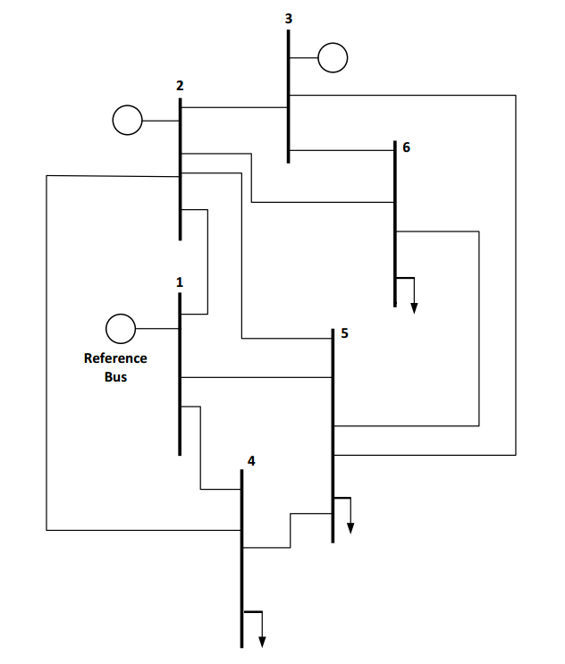

Figure IEEE 6 bus system

The calculation of PTDF using the formula: Bd*A*X_alt*(A_alt') generates PTDFs for transaction between directly connected buses.

The PTDF table for the IEEE 6-bus system (figure 3) is as follows:

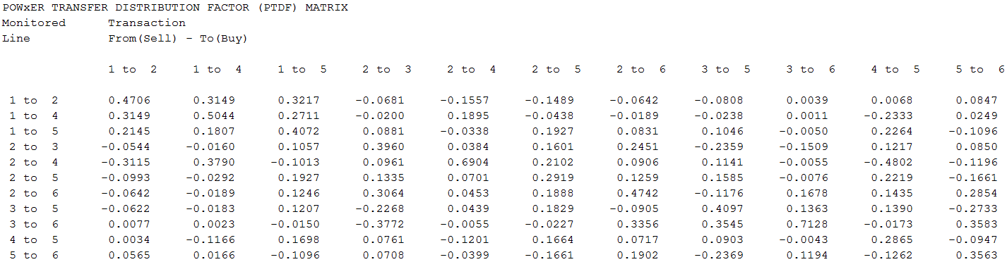

Figure PTDF table for 6 bus system

Now say if we had a transaction between two buses that are not directly connected, say between bus 4 and 6. As we can see from the PTDF table, for a transaction between bus 4 and 6 we do not have the PTDF values. So, in the subsequent section we will see how to generate PTDF values from any bus using the PTDF values from the above table.

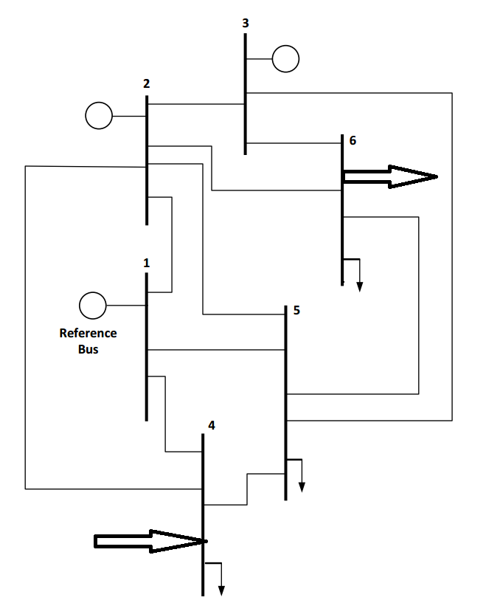

Figure transaction between bus 4 and 6

* + - 1. Procedure for computing PTDF from any bus to any bus

As seen in the earlier section, if we have a transaction between buses that are not directly connected, we do not have a way to calculate PTDF values using the formula mentioned above. So, first we need to find a relation to generate PTDF values from the PTDF table above. It turns out that the PTDF for transaction between bus 4 and 6 for the 6 bus case will be the sum of the PTDFs corresponding to transactions between 4->5 and 5->6. We will simulate a test case in PowerWorld to verify this result.

As seen in the earlier section, if we have a transaction between buses that are not directly connected, we do not have a way to calculate PTDF values using the formula mentioned above. So, first we need to find a relation to generate PTDF values from the PTDF table above. It turns out that the PTDF for transaction between bus 4 and 6 for the 6 bus case will be the sum of the PTDFs corresponding to transactions between 4->5 and 5->6. We will simulate a test case in PowerWorld to verify this result.

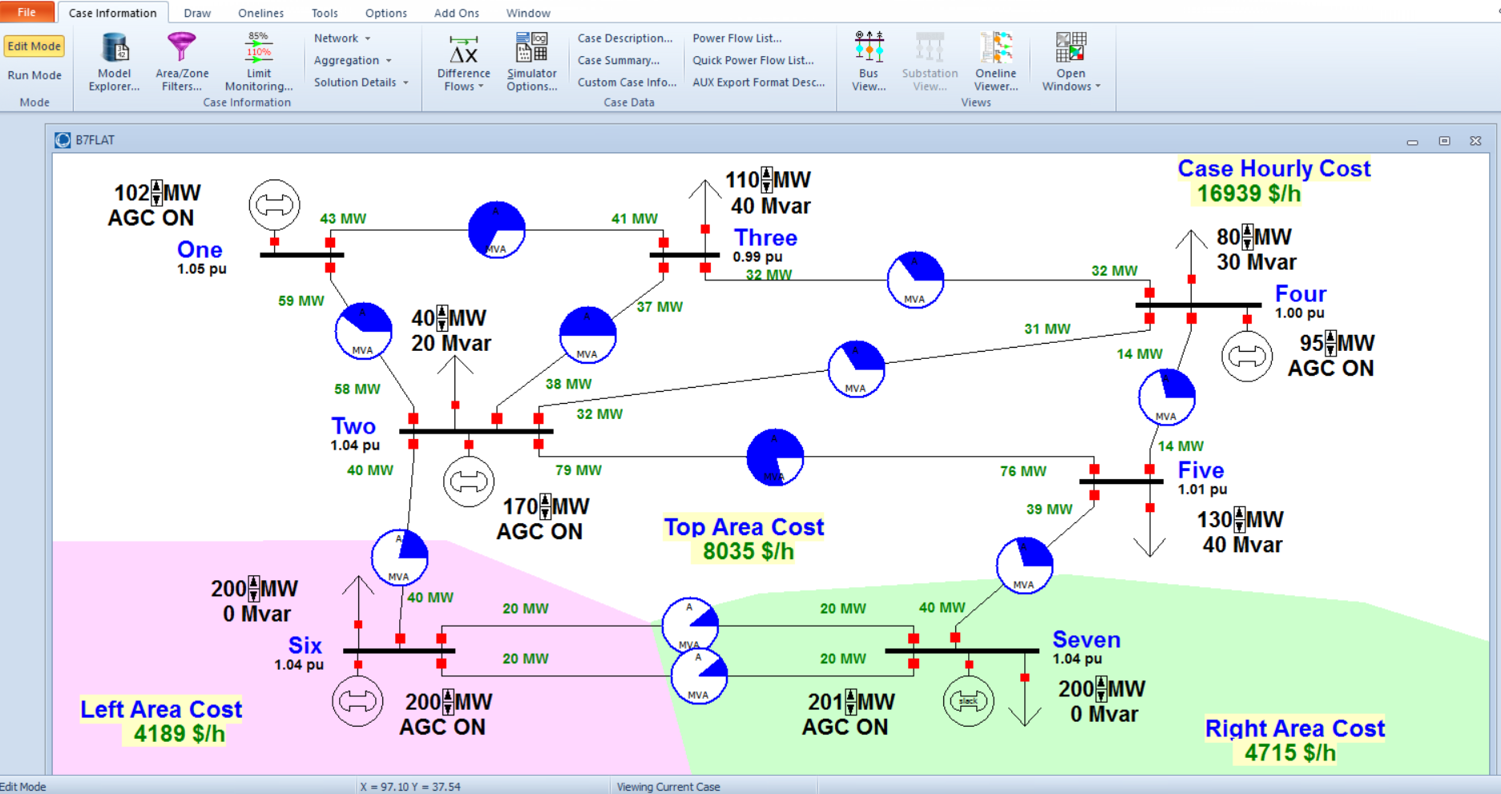

Figure simulation in PowerWorld

This is the 7 bus test system that we simulated in PowerWorld. Let’s say that we have a transaction between 1 and 6. As we can see, buses 1 and 6 are not directly connected. We will now verify that the PTDF of all lines corresponding to a transaction between buses 1 and 6 will be sum of PTDFs corresponding to a transaction between 1 to 2 and 2 to 6.

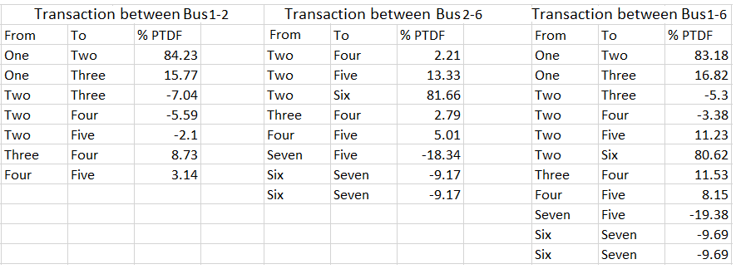

Figure % PTDF values corresponding to three different transactions

For line connecting bus three and four, its %PTDF value for transaction between bus 1 and 2 is: 8.73 – (1)

For the same line, the % PTDF value for transaction between bus 2 and 6 is: 2.79 – (2)

We have said that the PTDF for line connecting bus 3 and 4 will be the sum of (1) and (2). The sum is: 11.52 – (3)

From the above table, for transaction between bus 1 and 6 the PTDF value for line connecting bus 3 and 4 is: 11.53– (4)

As (3) equals (4), we have verified that the PTDF will indeed be the sum. We can verify this for all the lines.

* + - 1. Process flowchart for MATLAB implementation

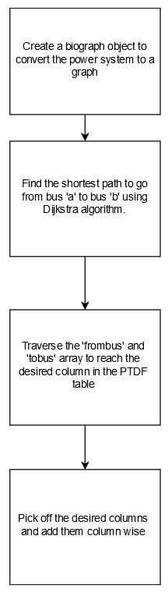

* 1. **Load Outage Distribution factor Calculation**

### Normal Case

Here we want the flow on line “l” from bus “i” to “j”, with the outage of line “k” from bus “n” to “m”.

We note that the original power flowing on line k from bus n to bus m is Pnm. When the injections ΔPn and ΔPm are added to bus “n” and bus “m” respectively, the resulting flow on line “k” is Ṗnm.

The opening of line k can then be simulated if,

ΔPn =Ṗnm

ΔPm = - Ṗnm

This means that all of the injected power into bus “n” flows in line “k” and out of bus “m” so that there is no flow through the breaker connecting bus “n” to the remainder of the system, and no flow through the breaker “m”

Now Ṗnm can be calculated easily if we note that the flow on line “k” for an injection into bus “n” and out of bus “m” is simply

Ṗnm =Pnm + PTDFn,m,k * ΔPn

We are using the PTDF to calculate how much of the injection ΔPn ends up flowing on line “k”, but by definition

ΔPn =Ṗnm

Then,

Ṗnm = Pnm + PTDFn,m,k * Ṗnm

Pnm =Ṗnm (1 - PTDFn,m,k )



Thus the LODF giving the change in flow on line “l” is simply,

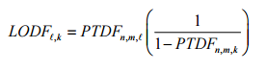

So that:



Thus we simply multiply the pre outage flow on line “k”, Pnm , times LODFl ,k to get the change in flow on line “l” , then the new flow on line “l”, “ḟl”, with an outage on line “k” is:

Or 

* + 1. Special Case

The diagonal terms in the PTDF matrix corresponding to radial lines are set to zero, but we must also check that PTDF for any pair ij and sr, with i = s and r = j, which is a term on the diagonal of the PTDF matrix, is not exactly 1. If it equals 1, then this means that all the flow injected into s and taken out at r is flowing through the line itself and there are no other paths from s to r for the power to flow. If such a line is opened it means that the network will be broken into two electrical islands.

It will also result in a term, (1− PTDFn,m,k) equal to zero and the formula for LODF above will get a divide by zero. Thus for any line whose PTDF diagonal is at or very close to 1 we simply set the PTDF to zero. The matlab program uses this expression to get the LODF factor matrix (the LODF matrix is numline X numline.



PTDF_denominator is the PTDF matrix with the PTDF diagonals that are 1 set to zero, then we extract its diagonals using the matlab expression diag ( PTDF_diagonals) the diagonals are now in a vector. diag(diag(PTDF_denominator)) converts the vector to a matrix with the terms on its diagonal and all zeros in the off diagonals. Eye is the identity matrix.

We now form the matrix eye(numline) – diag(diag(PTDF_denominator)) and invert it. Each term in the invert gives us the correct 1 - PTDFn m k to divide the PTDFn,m to get LODF.

The LODF matrix diagonals are set to zero to correspond with the fact that there can be no flow on a line which is opened.

**Chapter 3**

# **Description of MATLAB programs and User Manual**

* 1. **Description of MATLAB programs**

Entire program has been sub-divided in to following parts:

* **network_datainput_Excel.m**

In this part of the program, all the generator, bus and line data’s are read from various sheets of excel file using the MATLAB function xlsread. After completing the read operation, impedance matrix (Y-Matrix) has been constructed using the data. Later, the same Y-Matrix is used to calculate the entries of B’ matrix that is needed in DC power flow calculation.

* **DataSetUp.m**

This part sets up the data for calculations. The model is made up of buses connected by transmission paths. Each transmission path is made up of one or more circuits in parallel. “fbus” is the FROM bus number for the path and “tobus” is the TO bus number for the path. “xckt” is the inductive reactance of the circuit making up the path and “flowmax” is the max MW flow in each line.

Each function represents the cost of power at a generator. Each bid must have a separate function associated with it. Both the asking price of power, C(P) and the worth of power, W(P) functions are quadratic functions:

C(P) = A + B*P + C*P^2 and W(P)= A + B*P + C*P^2

Where

A = bidA

B = bidB

C = bidC

In all the examples here the A coefficient is zero and the coefficients for C(P) should all be positive or zero and the coefficients for W(P) should all be negative or zero. In addition, for generators, bidmin and bidmax are the min and max generation output respectively, and for loads, bidmin and bidmax are the min and max MW to be taken by the load. Finally, each bid is associated with one bus. If Line_flow_limits = 1, the limits will go in as entered on spreadsheet and if Line_flow_limits = 0, line flow limits ignored.

* **SetUpCalculation.m**

This contains a function “OPFcalc” which calls the routine “dfactcalc”. Given the segA, segB, segmin, segmax and segBus vectors, it calculates the optimal allocation of load and generation and returns the bus prices, the bus generations and bus loads. Each bus may have fixed load (baseload) and fixed generation (basegen) due to bilateral transactions that are outside the bidding process but must be accounted in the transmission loading.

* **MatrixInverse.m**

This code runs the code Lu decomposition to obtain triangle matrices and solves linear system for Identity matrix to get an inverse of a matrix.

* **Lu_Decomposition.m**

This code performs LU factorization. [L,U,P] = Lu(A) returns unit lower triangular matrix L, upper triangular matrix U, and permutation matrix P so that P*A = L*U.

* **BackwardSub.m**

It performs triangle Matrix Backward Substitution and solves the system of equations. This function is called by MatrixInverse.m.

* **ForwardSub.m**

It performs triangle Matrix Forward Substitution and solves the system of equations. This function is called by MatrixInverse.m.

* **calc_FACTORS.m**

This code builds the LODF and PTDF matrices. First we need to check to see that a line outage will not cause islanding. This is detected when the diagonal of any line in PTDF is very close to 1.0. In this case if such a line is detected, we force the PTDF(K,K) to zero so that we do not get a divide by zero and issue an error warning of islanding.

Here diag(PTDF) extracts the diagonals of PTDF matrix into a vector diag(diag(PTDF)) extracts diags of PTDF matrix and puts them into a matrix of the same size with all zeros in the off diagonals. Expression below multiplies the PTDF matrix by a matrix with diagonals equal to 1/(1 - PTDF(K,K))

It also calculates the single injection to line flow factor matrix. Call this the “afact” matrix. It calculates LODF by assuming a positive injection and this injection is compensated by an equal negative drop on the reference bus.

* **RunFACTORS.m**

This contains mainly the function calls, starting with SetUpCalculation(OPFdata).

* **Prepare_Data_for_any_bus_to_any_bus**

This code prepares the data required for PTDF calculation of any bus to any bus by constructing PTDF matrices

* **PTDF_for_any_bus_to_bus.m-**

This program calculates PTDF for transaction from any bus to any bus if the PTDF values for directly connected buses is given.

* 1. **User Manual** 
     1. Description

The following Excel Spreadsheet data files come with the factors calculator.

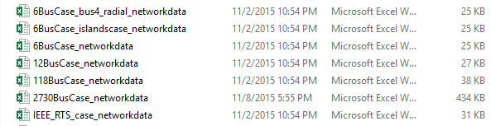

The 6 Bus Case files except from the file “2730BusCase_networkdata” are from the textbook - Power Generation, Operation and Control, 3rd Edition by Allen J. Wood, Bruce F. Wollenberg, Gerald B. Sheble. Content of these files are explained below:

File "6BusCase_networkdata.xlsx has all line in.

File “12BusCase_networkdata.xlsx” is made up of two identical sets of buses and line from the 6 Bus Case. One set is buses 1 to 6 and the other is set 7 to 12. There are three tie lines connecting these islands, they are lines 3-9, 5-8 and 4-10. If two of these three tie line are opened you also have another island case.

File “118BusCase_networkdata.xlsx” is the IEEE 118 bus test case.

File “6BusCase_bus4_redial_networkdata.xlsx” has lines 1-4 and 4-5 opened at the start by setting the “status” field equal to zero. This leaves bus 4 as a radial bus.

File “6BusCase_islandcase_networkdata.xlsx” lines 2-4, 2-5, and 3-5 out so that line 1-4 connects two islands if removed.

File “IEEE_RTS_case_networkdata.xlsx” is the IEEE “Reliability Test Case” (i.e. RTS) system.

File “2730BusCase_networkdata.xlsx” is a 2730 bus test case

NOTE: If you create any new data files for testing, the last 11 characters of the file name must be “*networkdata” (without the quote marks) in order for the program that reads the files to pick out the correct files.

* + 1. Procedure to Run the Program:

1. Enter “RunFACTORS” in MATLAB work area. All the Excel spreadsheet data files mentioned above will appear in a selectin window.
2. User has to double click on one of the files and the program will then execute on that file.
3. If you want to edit any data file just use Excel spreadsheet program, and be sure to SAVE the file before running the MATLAB program (you don’t have to close the spreadsheet program when you run MATLAB)
4. Program displays PTDF and LODF data’s for the combinations as per the connection.
5. In case user would like to know PDTF for any specific combination, other than the displayed once, he will have to run the MATLAB program: “PTDF_for_any_bus_to_bus.m”. (Note – This program is to be executed only after running the program“RunFACTORS”)

The program will prompt you to enter the bus numbers where power is being injected and withdrawn. Enter the bus numbers and the PTDF values for that particular transaction will be displayed.

This is an example for the IEEE 6 bus case wherein we are injecting power at bus 6 and removing power at bus

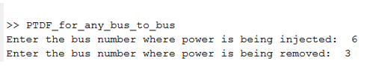

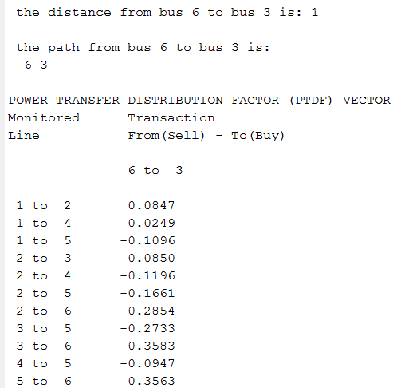

Chapter 4

# **Conclusion**

Power Transfer Distribution Factors describe the way power system behaves in case of a certain transaction between a pair of buses. Since the method is based on DC power flow equations, power flow in the branches is calculated very quickly without having to perform many iterations. Since the Power transfer Distribution Factor is linear, superposition is possible where different transactions can be superimposed onto each other. We have extended the program to generate PTDF factors in full generality, that is, from any bus to any bus by making use of the existing PTDFs between directly connected buses. The PTDF of a line corresponding to a transaction from any bus to any bus is the addition of PTDFs of the lines between buses falling in the shortest path.

Usage of sparse techniques in handling the data has resulted in significant amount of memory saving as it stores only the nonzero elements of the matrix, and also there is an improvement in speed of data processing as sparse technique reduces the computation time by eliminating operations on zero elements. The effectiveness of these techniques is validated as shown in the test case result presented.

LU factorization method instead of inverting the matrix has reduced the number of operations that is needed to evaluate the PTDF expression. Because once we factor the matrix, we can save the factorization and solve the equation of the type Ax = b for any number of b’s. Also, it is more efficient compared to inverting the matrix. Factorization takes O(n3) operations but once the matrix is factored, solving Ax = b takes only O(n2) operations. Additionally, solving the system is more numerically accurate than inverting a matrix and then performing matrix multiplication.

By calculating Line Outage Distribution Factors, a very fast procedure can be set up to test all lines in the network for an overload when an outage of a line occurs. Furthermore, the overload can be reported to the operations personal in the form of an alarm message.

Future work can be done to extend this project to calculate Available Transfer Capacity of the network. Further development of this application would provide the building blocks for developing a mathematical model for an optimal load shedding scheme for severe contingency cases.

# **References**

1. FERC and NERC. (2012, Apr.) Arizona-southern California outages on September 8, 2011: Causes and recommendations. [Online].

Available: http://www.ferc.gov/legal/staff-reports/04-27-2012-ferc-nerc-report.pdf

1. U.S.-Canada Power System Outage Task Force. (2004, Apr.) Final report on the august 14th blackout in the United States and Canada: causes and recommendations. [Online].

Available: <http://energy.gov/sites/prod/files/oeprod/DocumentsandMedia/BlackoutFinal-Web.pdf>

1. Standard MOD-030-1 - Flowgate Methodology. (2008,Feb.) Standard Development Roadmap [Online].

Available: <http://www.nerc.com/pa/Stand/Project%20200607%20MODV0Revision%20DL/MOD-030-1_clean_01Feb08.pdf>

1. Calculation of Available Transfer Capability (ATC). [Online].

Available: [http://nptel.ac.in/courses/108101005/transmission congestion management /calculation of atc.html](http://nptel.ac.in/courses/108101005/transmission%20congestion%20management%20/calculation%20of%20atc.html)

1. Power Generation, Operation and Control, 3rd Edition by Allen J. Wood, Bruce F. Wollenberg, Gerald B. Sheble ISBN: 978-0-471-79055-6.

**Chapter 6**

# **Program Output**

## **Test Case: 6 bus System:**

B_diag =

(1,1) 5.0000

(2,2) 5.0000

(3,3) 3.3333

(4,4) 4.0000

(5,5) 10.0000

(6,6) 3.3333

(7,7) 5.0000

(8,8) 3.8462

(9,9) 10.0000

(10,10) 2.5000

(11,11) 3.3333

A_alt =

(1,1) 1

(2,1) 1

(3,1) 1

(1,2) -1

(4,2) 1

(5,2) 1

(6,2) 1

(7,2) 1

(4,3) -1

(8,3) 1

(9,3) 1

(2,4) -1

(5,4) -1

(10,4) 1

(3,5) -1

(6,5) -1

(8,5) -1

(10,5) -1

(11,5) 1

(7,6) -1

(9,6) -1

(11,6) -1

Monitored GENERATOR

Line

1 2 3 4 5 6

1 to 2 0.0000 -0.4706 -0.4026 -0.3149 -0.3217 -0.4064

1 to 4 0.0000 -0.3149 -0.2949 -0.5044 -0.2711 -0.2960

1 to 5 0.0000 -0.2145 -0.3026 -0.1807 -0.4072 -0.2976

2 to 3 0.0000 0.0544 -0.3416 0.0160 -0.1057 -0.1907

2 to 4 0.0000 0.3115 0.2154 -0.3790 0.1013 0.2208

2 to 5 0.0000 0.0993 -0.0342 0.0292 -0.1927 -0.0266

2 to 6 0.0000 0.0642 -0.2422 0.0189 -0.1246 -0.4100

3 to 5 0.0000 0.0622 0.2890 0.0183 -0.1207 0.1526

3 to 6 0.0000 -0.0077 0.3695 -0.0023 0.0150 -0.3433

4 to 5 0.0000 -0.0034 -0.0795 0.1166 -0.1698 -0.0752

5 to 6 0.0000 -0.0565 -0.1273 -0.0166 0.1096 -0.2467

POWER TRANSFER DISTRIBUTION FACTOR (PTDF) MATRIX

Monitored Transaction

Line From(Sell) - To(Buy)

1 to 2 1 to 4 1 to 5 2 to 3 2 to 4 2 to 5 2 to 6 3 to 5 3 to 6 4 to 5 5 to 6

1 to 2 0.4706 0.3149 0.3217 -0.0681 -0.1557 -0.1489 -0.0642 -0.0808 0.0039 0.0068 0.0847

1 to 4 0.3149 0.5044 0.2711 -0.0200 0.1895 -0.0438 -0.0189 -0.0238 0.0011 -0.2333 0.0249

1 to 5 0.2145 0.1807 0.4072 0.0881 -0.0338 0.1927 0.0831 0.1046 -0.0050 0.2264 -0.1096

2 to 3 -0.0544 -0.0160 0.1057 0.3960 0.0384 0.1601 0.2451 -0.2359 -0.1509 0.1217 0.0850

2 to 4 -0.3115 0.3790 -0.1013 0.0961 0.6904 0.2102 0.0906 0.1141 -0.0055 -0.4802 -0.1196

2 to 5 -0.0993 -0.0292 0.1927 0.1335 0.0701 0.2919 0.1259 0.1585 -0.0076 0.2219 -0.1661

2 to 6 -0.0642 -0.0189 0.1246 0.3064 0.0453 0.1888 0.4742 -0.1176 0.1678 0.1435 0.2854

3 to 5 -0.0622 -0.0183 0.1207 -0.2268 0.0439 0.1829 -0.0905 0.4097 0.1363 0.1390 -0.2733

3 to 6 0.0077 0.0023 -0.0150 -0.3772 -0.0055 -0.0227 0.3356 0.3545 0.7128 -0.0173 0.3583

4 to 5 0.0034 -0.1166 0.1698 0.0761 -0.1201 0.1664 0.0717 0.0903 -0.0043 0.2865 -0.0947

5 to 6 0.0565 0.0166 -0.1096 0.0708 -0.0399 -0.1661 0.1902 -0.2369 0.1194 -0.1262 0.3563

LINE OUTAGE DISTRIBUTION FACTOR (LODF) MATRIX

Monitored Outage of one circuit

Line From - To

1 to 2 1 to 4 1 to 5 2 to 3 2 to 4 2 to 5 2 to 6 3 to 5 3 to 6 4 to 5 5 to 6

1 to 2 0.0000 0.6353 0.5427 -0.1127 -0.5031 -0.2103 -0.1221 -0.1369 0.0135 0.0096 0.1316

1 to 4 0.5948 0.0000 0.4573 -0.0331 0.6121 -0.0618 -0.0359 -0.0403 0.0040 -0.3269 0.0387

1 to 5 0.4052 0.3647 0.0000 0.1458 -0.1090 0.2721 0.1580 0.1772 -0.0174 0.3174 -0.1703

2 to 3 -0.1029 -0.0323 0.1783 0.0000 0.1242 0.2262 0.4662 -0.3995 -0.5253 0.1706 0.1320

2 to 4 -0.5884 0.7647 -0.1708 0.1591 0.0000 0.2969 0.1724 0.1933 -0.0190 -0.6731 -0.1858

2 to 5 -0.1875 -0.0589 0.3250 0.2209 0.2264 0.0000 0.2394 0.2685 -0.0264 0.3110 -0.2580

2 to 6 -0.1213 -0.0381 0.2102 0.5073 0.1464 0.2667 0.0000 -0.1992 0.5842 0.2011 0.4433

3 to 5 -0.1175 -0.0369 0.2036 -0.3755 0.1418 0.2583 -0.1720 0.0000 0.4747 0.1948 -0.4246

3 to 6 0.0146 0.0046 -0.0253 -0.6245 -0.0176 -0.0321 0.6382 0.6005 0.0000 -0.0242 0.5567

4 to 5 0.0065 -0.2353 0.2865 0.1259 -0.3879 0.2350 0.1365 0.1530 -0.0150 0.0000 -0.1471

5 to 6 0.1067 0.0335 -0.1849 0.1172 -0.1288 -0.2346 0.3618 -0.4013 0.4158 -0.1769 0.0000

Elapsed time is 0.135725 seconds.

Below is the comparison of sparse and non-sparse storage of the matrix “B_Bdiag” which stores susceptance data of lines between the buses.

|  |  |  |  |
| --- | --- | --- | --- |
| **Number of buses** | **Total number of entries** | **Number of zero entries** | **Number of non-zero entries** |
| 6 | 121 | 110 | 11 |
| 12 | 625 | 600 | 25 |
| 118 | 34596 | 34410 | 186 |
| 2370 | 15729156 | 15725190 | 3966 |

Note - As we can see from above, number of non-zero entries are very few compared to zero entries.

Next, the results for PTDF calculation from any bus to any bus are presented:

**PTDF_for_any_bus_to_bus**

Enter the bus number where power is being injected: 1

Enter the bus number where power is being removed: 6

the distance from bus 1 to bus 6 is: 2

the path from bus 1 to bus 6 is: 1 2 6

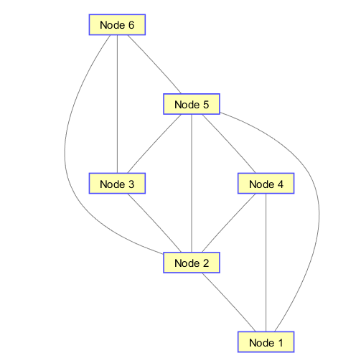

Figure 8 Six bus graph equivalent

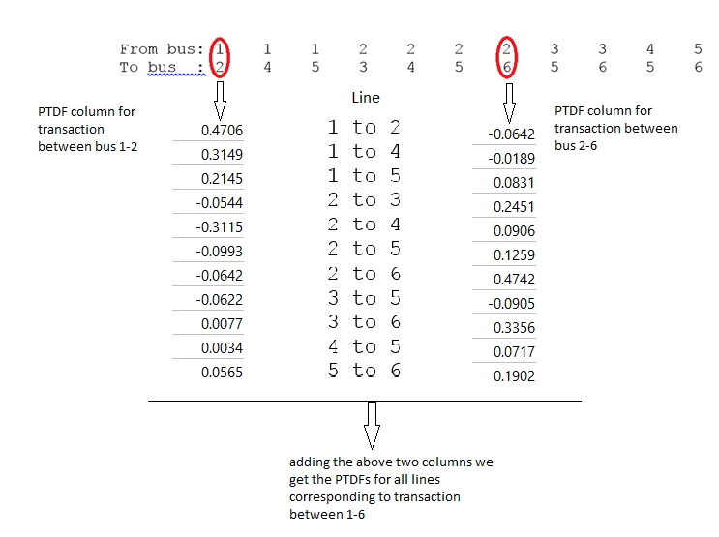

POWER TRANSFER DISTRIBUTION FACTOR (PTDF) VECTOR

Monitored Transaction

Line From(Sell) - To(Buy)

1 to 6

1 to 2 0.4064

1 to 4 0.2960

1 to 5 0.2976

2 to 3 0.1907

2 to 4 -0.2208

2 to 5 0.0266

2 to 6 0.4100

3 to 5 -0.1526

3 to 6 0.3433

4 to 5 0.0752

5 to 6 0.2467